Design Software Document
Version 1.0
GPL v2????

Graphical User Interface (GUI)

for the Deconvolution of Specific Inherent Optical Properties (SIOPS)
from hyperspectral remote sensing reflectance

Table of Contents
Introduction 4
What is PlanarRad ? 4
Getting started 4
I – The bar menu : 5
5
II – The attached buttons 5
III – The first tab 6
A – The batch file 7
B – Display results 8
IV – The second tab 8
A – The tool choice 9
B – The reverse way thanks to the batch file 9
V – The error case 10

Introduction

This manual will explain for non-technical people how works the Graphical User Interface (GUI) to run PlanarRad in batch mode, run the deconvolution methodologies using data that you will transmit and display the results thanks to curves and numbers.
As the number of the variations in optical properties is often large, it is useful for a user to run PlanarRad many times with small variations in the inputs. Furthermore, as many modern desktop computers have multiple processing cores, processing time may be reduced by running multipleinstances of PlanarRad at the same time. The task will require the tool to run multiple instances of PlanarRad multiple tim es for all user defined inputs. So, The GUI developed will help the user to use the scientific tool PlanarRad and make a lot of tests easily.
Concretely the GUI that can:
- run PlanarRad in batch mode
- run the deconvolution methodologies over the outputs
- display the results.

What is PlanarRad ?

PlanarRad, developed by John Hedley, in 2008 and using the GPL public licence. It is a free open-source software for modelling light in natural waters or other homogeneous scattering and absorbing media.
It has the ability to synthetically produce remote sensing reflectance through numerical radiative transfer modelling. PlanarRad lacks some features that include : the ability to easily do batch runs of differing optical properties or the ability to model the optical properties via bio-optical models. These features remain the subject of further investigation and development.

More information and download PlanarRad on :
http://www.planarrad.com/index.php?title=PlanarRad

Getting started

How to install it.

Link to download :

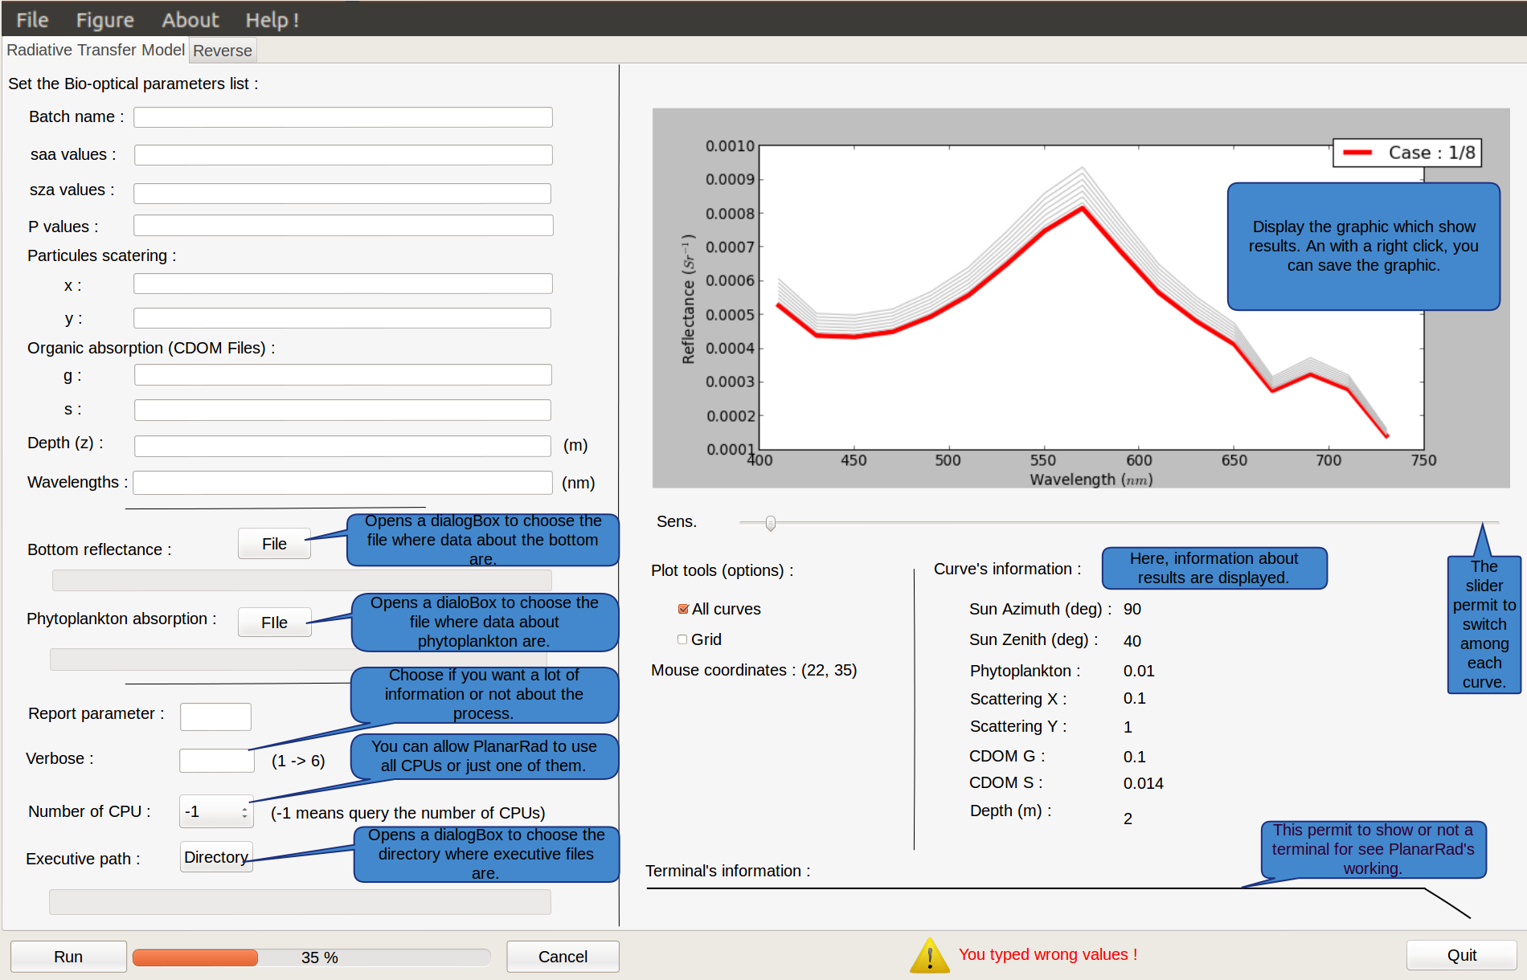

I – The bar menu :
The bar menu is composed of different tabs.
In the first one, named “File”, you can open a file with results inside to display them, you can run PlanarRad or you can quit the gui.
In “Figure”, you can save the figure with a default name or with a chosen name.
In “About”, you can obtain information about this gui.
In “Help !”, you have the possibility to display the log file or to open a webpage containing information about PlanarRad and how it works.

II – The attached buttons

Firstly, there is a part in the GUI of it that will never change. There is a “Run” button which execute the software PlanarRad thanks to the data filled in the GUI.
Secondly, the progress bar show if the software PlanarRad succeed.
Thirdly, the “Cancel” button permit to you to stop PlanarRad during its progress.
Finally, the “Quit” button permit to quit the GUI.

III – The first tab

Illustration 1: Preview of the first tab.
In the first tab of the GUI, there is two different parts. One of these part is useful to create the batch file using by PlanarRad, and the other is useful to plot results and display them.

A – The batch file

This part of the GUI on the left, permit to create the batch file, the file that PlanarRad use to work.
There it is a explanation about every things you need update :
- The “batch name” : It will be the name of the file generated by the GUI for PlanarRad. An example of it is on : https://marrabld.github.io/planarradpy/ (see “example input parameter file”).
- The “saa values” :
- The “sza values” :
- The “P values” :
- The “particles scattering (x,y)” :
- The “organic absorption (CDOM files) (g,s) :
- The “depth (s)” :
- The “wavelengths” :
- The “bottom reflectance” : It is the path to the file containing data about that.
- The “phytoplankton absorption” : It is the path to the file containing data about that.
- The “report parameter” :
- The “verbose” value :
- The “number of CPU” : It is to know how many CPU the software can use to run.
- The “executive path” : It is the directory where there is executives files use by PlanarRad to run. Normally, there are in : jude2_install/bin .

B – Display results

This second section of the first tab on the right is for display results.
The first part of this section is the graphic. It shows plot results for all tests that PlanarRad generated. The second have to goal, one is to analyse results and the other to display results numbers.
There it is a explanation about every things you can change in the “Plot tools” section :
- The check box “All curves” : serves to show all curves or not.
- The slider “sens” : It serves to display curves one by one when the check box is not checked. Otherwise, the slider serves to highlight one among others.
- The check box “Grid” : It permits to show or not a grid on the graphic.
- The “Open result file” button : This button permit to open another file result created already to display its information.
- The “mouse coordinates : (X,Y)” : It shows you the coordinates of the arrow cursor on the artist.

The second part shows the results of one curve. Indeed, each curve will have its information displayed whether it be with one curve in red to compare it with others in black or when there is only one curve displayed.
There it is a explanation about curves' information :
- “Sun Azimuth (deg)” :
- “Sun Zenith (deg)” :
- “Phytoplankton” :
- “Scattering X” :
- “Scattering Y” :
- “CDOM G” :
- “CDOM S” :
- “Depth (m)” :

IV – The second tab
Illustration 2 : Preview of the second tab.

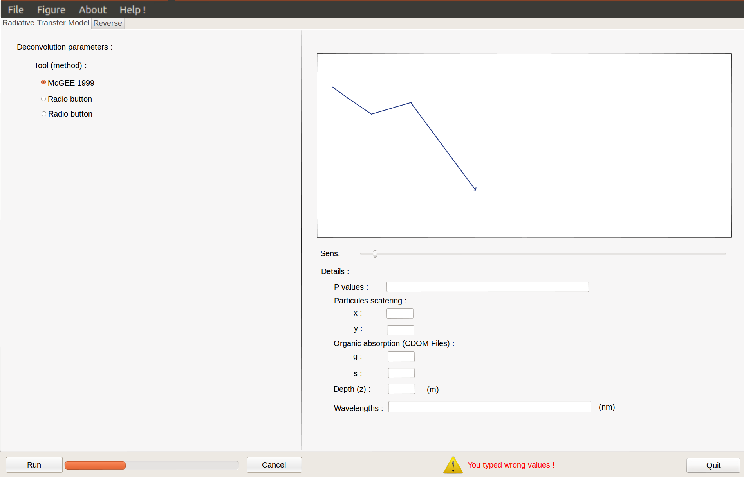

A – The tool choice

B – The reverse way thanks to the batch file

V – The error case
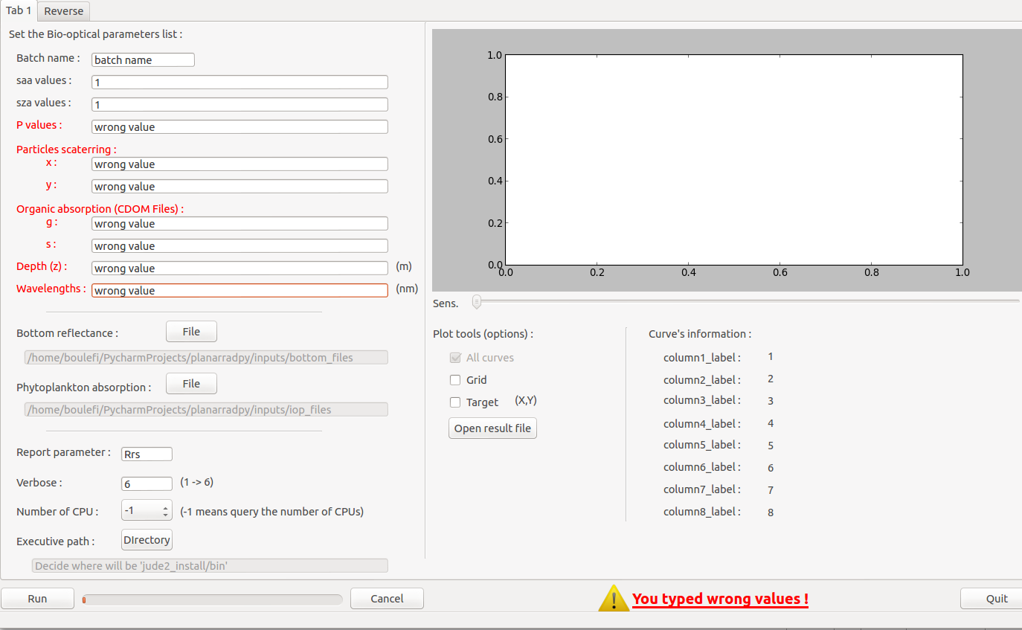

When the user type a wrong value, the GUI will prevent the user showing in red the labels where the mistake has made and displaying a warning message with an exclamation mark icon. It is when you fill the blanks with not valid text. That is permit to you to know when you made a mistake and where to correct it. For example, this message can be display if you type numbers instead of letters.

